OpenMP

OpenMP (https://www.openmp.org) enables parallel computing on single computer by taking advantage of the multiple cores shipped on modern CPUs.

Windows

1. Go to http://tdm-gcc.tdragon.net/. Download TDM_GCC.

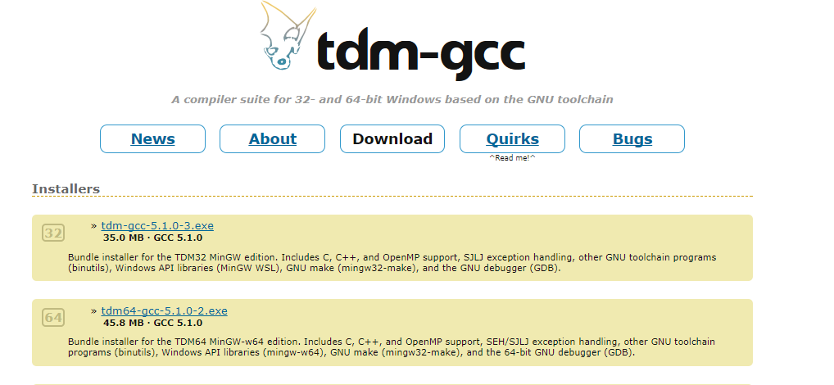

2. Uncheck the box “Check for updated files on the TDM-GCC server” and click “Create”.

3. Click “Next” to see the installation setup. Check the box “openmp” under “gcc”.

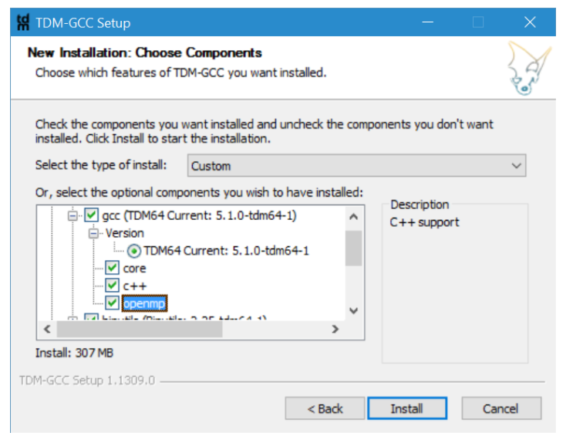

4. Now, you can use gcc -fopenmp to run OpenMP on you PC.
Mac OS X

1. Install Homebrew (https://brew.sh)

2. brew install gcc (current version 9.1.0). Add PATH if necessary

3. run your test code.

Please refer to the following webpage for more information about installation OpenMP on Mac.
1. https://clang-omp.github.io
2. http://openmp.llvm.org
3. http://thecoatlessprofessor.com/programming/openmp-in-r-on-os-x/

