Package ‘Famdenovo’

Type Package
Title TP53 mutation carrier estimation
Version 0.1.1
Date 2020-05-16
Author Fan Gao, Wenyi Wang, Xuedong Pan
Maintainer Matthew Montierth <mdmontierth@mdanderson.org>, Wenyi Wang <wwang7@mdanderson.org>
Description This is a software that predicts the de novo status of deleterious germline mutation(s) in Mendelian diseases based on family history. Currently we apply Famdenovo to de novo TP53 mutations. For new functions for other genes, e.g., BRCA1/2, please check http://https://bioinformatics.mdanderson.org/public-software/famdenovo/.
License GPL-2

How to install
If you have not installed "Famdenovo", download it from "http://bioinformatics.mdanderson.org/main/Famdenovo" and install it from local source in your R console by typing:
install.packages("where_you_saved_the_file/Famdenovo_0.1.1.tar.gz", repos = NULL, type = "source")
Or, install from GitHub:
library(devtools)
install_github("wwylab/Famdenovo_0.1.1")

How to use
Step 1. Load package
library(Famdenovo)

Step 2. Call "Famdenovo()" function
Famdenovo(family, cancer, mutation, person.id, gene = “TP53”)

Format of the input files
Famdenovo requires three data sets as input: family, cancer, and mutation information..

family: Family Information Data

The input should be a data frame. The family data should include the following columns with the corresponding column names:
id: Index of the person. All individuals should from one family.
fid: Index of the person's father. If the individual is the founder of the pedigree, set it as NA.
mid: Index of the person's mother. If the individual is the founder of the pedigree, set it as NA.
gender: Gender of the person. 0 - female; 1 - male
age: Age of the person. If the individual is alive, it is their current age. Otherwise, set it as the age at death.

Example Code:
Data(“TP53.test1.family”)
TP53.test1.family

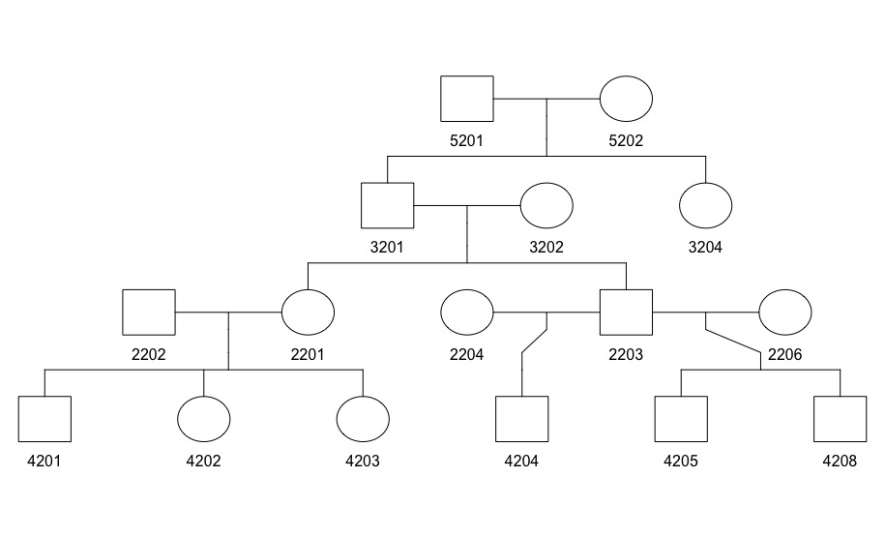
Figure 1. An example of a pedigree structure

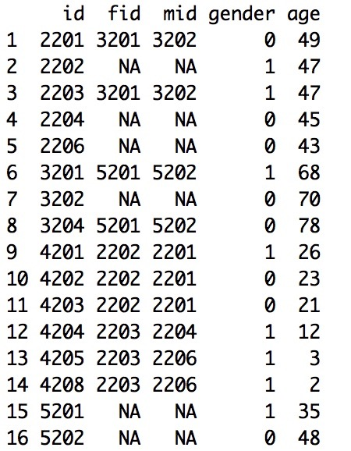
Figure 2. Example of the family data for a pedigree in Figure 1.

cancer: Cancer Information Data

The input should be a data frame. The cancer data should include the following columns with the corresponding column names:
id: index of the person
cancer.type: Type of the cancer. We divided all the cancers into 11 groups according to NCCCN Guidelines Version 1.2012 Li-Fraumeni Syndrome criteria. Check "LFSpro.cancer.type" for details.
diag.age: Age when the individual was diagnosed with cancer.

Example Code:
Data(“TP53.test1.cancer”)
TP53.test1.cancer

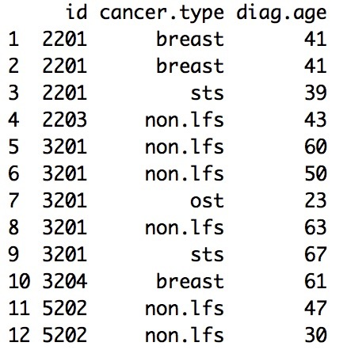
Figure 3. An example of the cancer file

mutation: Mutation Information Data

The input should be a data frame. The mutation data should include the following columns with the corresponding column names:
id: Index of the person
mut.state: Mutation status of the person. "W" - wild type; "M" - mutated. Individuals who are not sequenced are not included in the mutation information data.

Example Code:
Data(“TP53.test1.mutation”)
TP53.test1.mutation

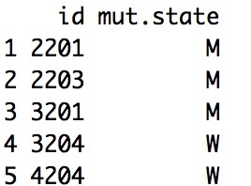
Figure 4. An example of the mutation file

person.id
The input should be either character string(s) or numerical value(s) of the person(s) you want to analyze.

gene
The input should be character string(s). The default value is "TP53". We will add other genes in the future. For new functions for other genes, e.g., BRCA1/2, please check https://bioinformatics.mdanderson.org/public-software/famdenovo/

Format of the output file
The output is the probability of any deleterious TP53 mutation being de novo, one mutation carrier per row. Each row contains three elements: "family id", "individual id" and "prob.denovo".

Here is an example:
[1] "The following ids are not carriers: 1002, 1003"
id prob.denovo
1 2201 0.0001205471
2 2203 0.0001105599
3 3201 0.0126455556

